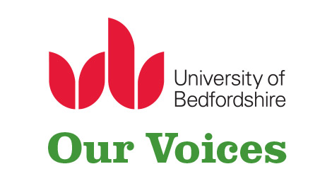

Information sheet
Our Voices Too – Peer Interventions Research Study

What is the research about?
The International Centre: Researching child sexual exploitation, violence and trafficking (IC) based at the University of Bedfordshire, UK, is coordinating a research study exploring peer interventions with young people who have experienced sexual violence. This research is part of a project entitled Our Voices Too, funded by Oak Foundation, that aims to promote the involvement of young people affected by sexual violence in research, policy and practice.

In the context of this study, ‘peer interventions’ may include a variety of models that rely on peer-to-peer interaction, support and education such as: one-to-one or group-based peer support, peer-led self-help groups, peer mentoring or online support.
We are particularly interested in exploring the following key question:
- What do peer interventions for young people (aged 10-24) who have experienced sexual violence look like and involve?
- How are peer interventions experienced and received by young people, parents and practitioners?
- What role do peer interventions play for young people affected by sexual violence (e.g. wellbeing)?
- How are peer interventions initiated, supported, monitored and ended?

Who is conducting and overseeing the research?
Two researchers at the IC are conducting this research: Silvie Bovarnick, a Research Fellow on Youth Participation and European Knowledge Exchange and Delphine Peace, a Research Assistant on the Our Voices Too project. The research has received ethical approval from the Ethics Committee of the Institute of Applied Social Research and the University’s Research Ethics Committee at the University of Bedfordshire.

What is the purpose of this online survey?
The purpose of this online survey is to learn more about models of peer interventions for young people who have experienced sexual violence and to understand how these models work along with the strengths and weaknesses of such interventions.
Do I have to take part?
No, your participation is entirely voluntary and it is your choice whether you would like to take part in the online survey or not.

What will you do with the information that I tell you?
In compliance with the GDPR, all data collected through this survey will remain confidential and the information shared will be anonymised. Care will be taken to ensure that all identifying features of respondents have been removed and respondents will only be identified by a generic description of their professional role (e.g. ‘academic’, ‘practitioner’, ‘NGO worker’, ‘volunteer’, etc.). Details of respondents’ names, specific roles or organisations will be kept confidential.

The data emerging from this online survey will be automatically stored in the ‘back-end’ of the project website. This is an administrative area that allows us to configure the user interface of the website. It also contains a database where any information entered on the website is stored. It is password protected and all staff with access to the ‘back-end’ of the website have been trained and fully understand the importance of complying with data protection and confidentiality. Data will remain securely stored for the duration of the project, until November 2019, and will then be destroyed. The anonymised data will be retained indefinitely in order to allow for re-analysis at a later stage. We will use the findings to help us plan the next stages of this project and we will also use the findings in academic writing.

As part of this study, we will also be conducting key informant interviews and case studies to gather more detailed data. We give you the opportunity to provide your email address if you feel that your organisation might be relevant and that you would be happy to be contacted by us for follow up.

Can I change my mind at any time?
If you decide at a later date, before 30 November 2018, that you do not wish us to use your data in the research, it can be removed and will not be included in any reports or articles.

What if I’m not happy about the research or want to make a complaint?
If you would like to complain about any aspect of the research you can make a complaint to the University of Bedfordshire. You can contact Dr Helen Beckett who is the Director of the International Centre at the University of Bedfordshire. Dr Beckett can be contacted on +44 (0) 7725) 217231. Dr Beckett will then follow up on any complaints with the project team.

Further information

If you are interested in taking part and/or have any questions or require any further information please do not hesitate to contact Delphine Peace / delphine.peace@beds.ac.uk

